NAME:KONGARA JOGESH
REG:192525035

EX:2 Design and Configuration of Star Topologies using Packet Tracer.
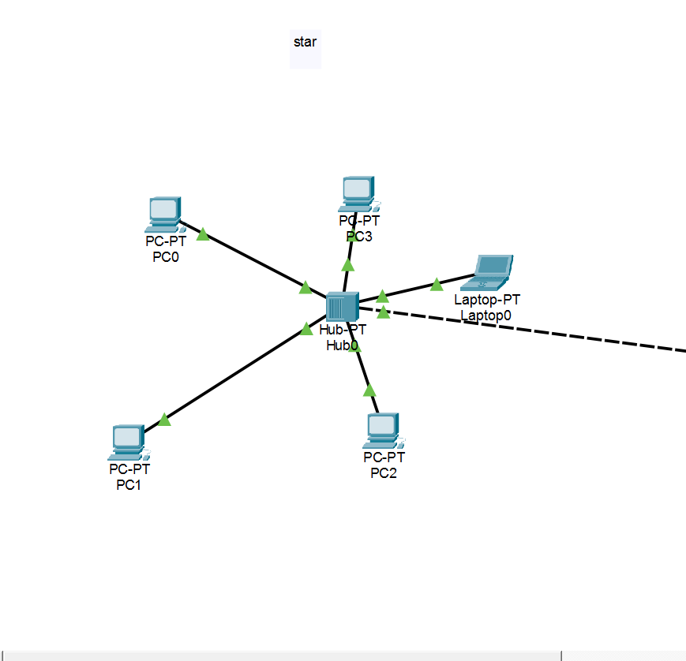

EX:3 Design and Configuration of BUS Topologies using Packet Tracer.

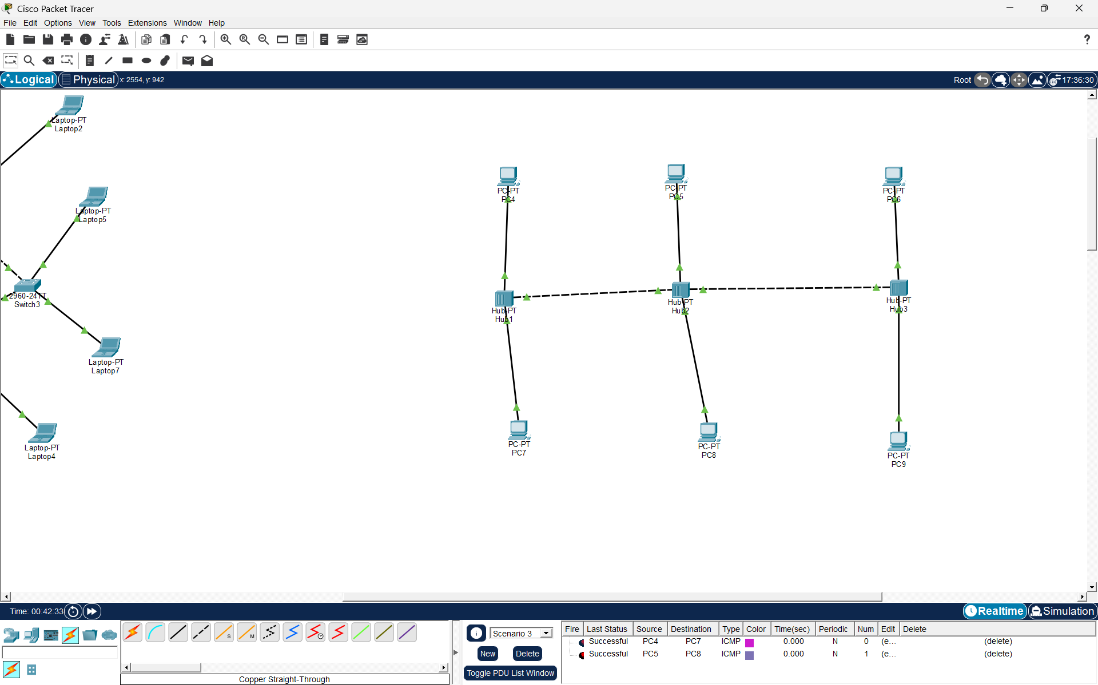

EX:4 Design and Configuration of RING Topologies using Packet Tracer.

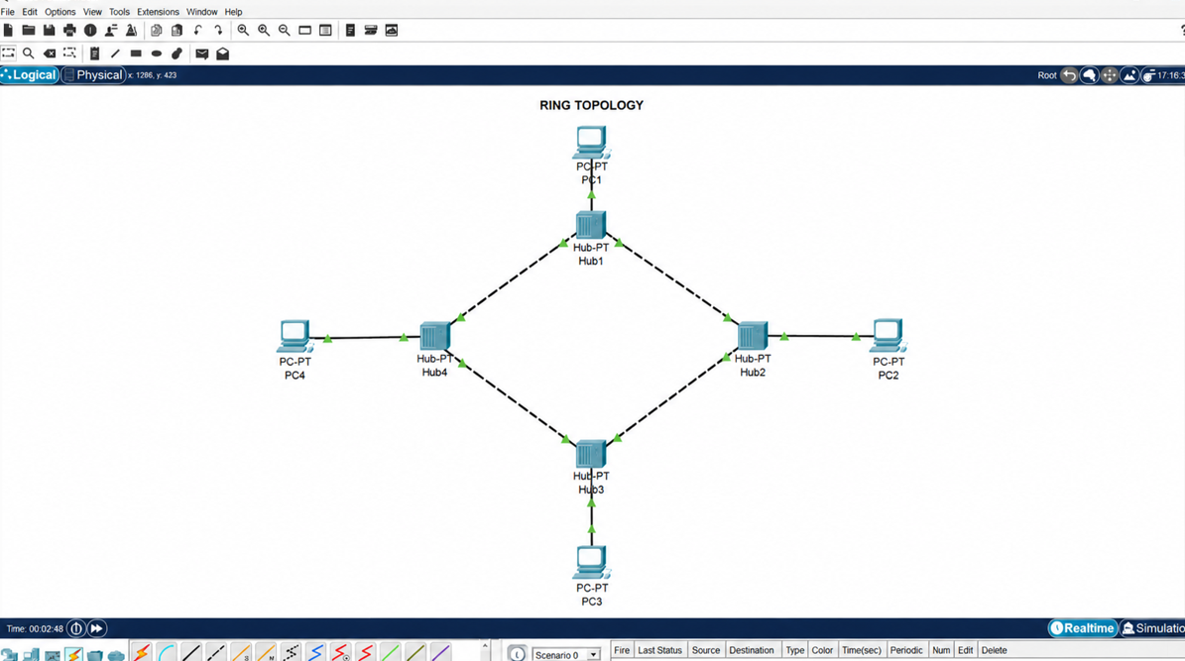
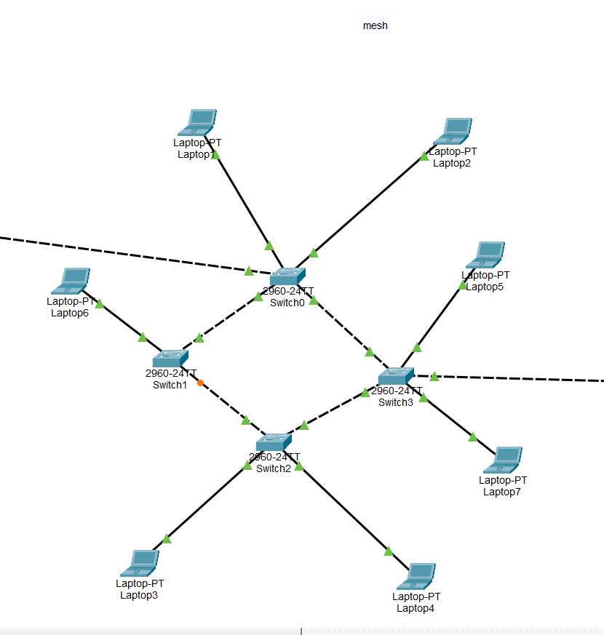
EX:5 Design and Configuration of Mesh Topologies using Packet Tracer.

EX:6 Design and Configuration of Tree Topologies using Packet Tracer.

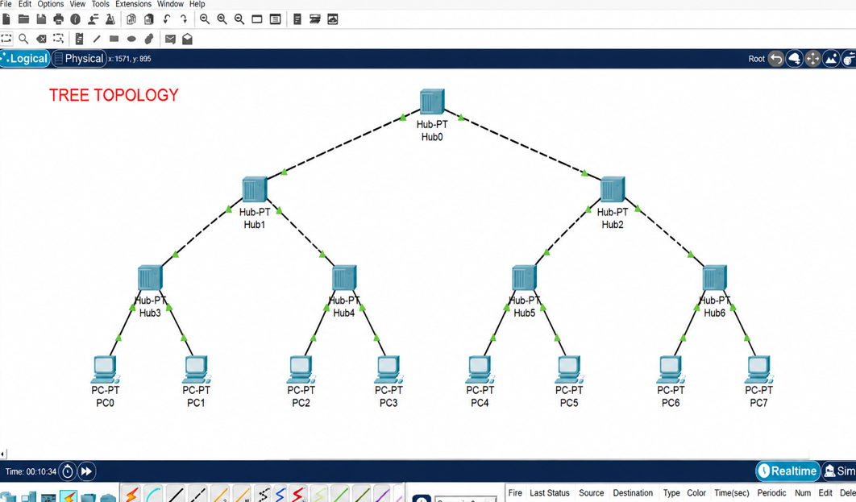

EX:7 Design and Configuration of Hybrid Topologies using Packet Tracer.
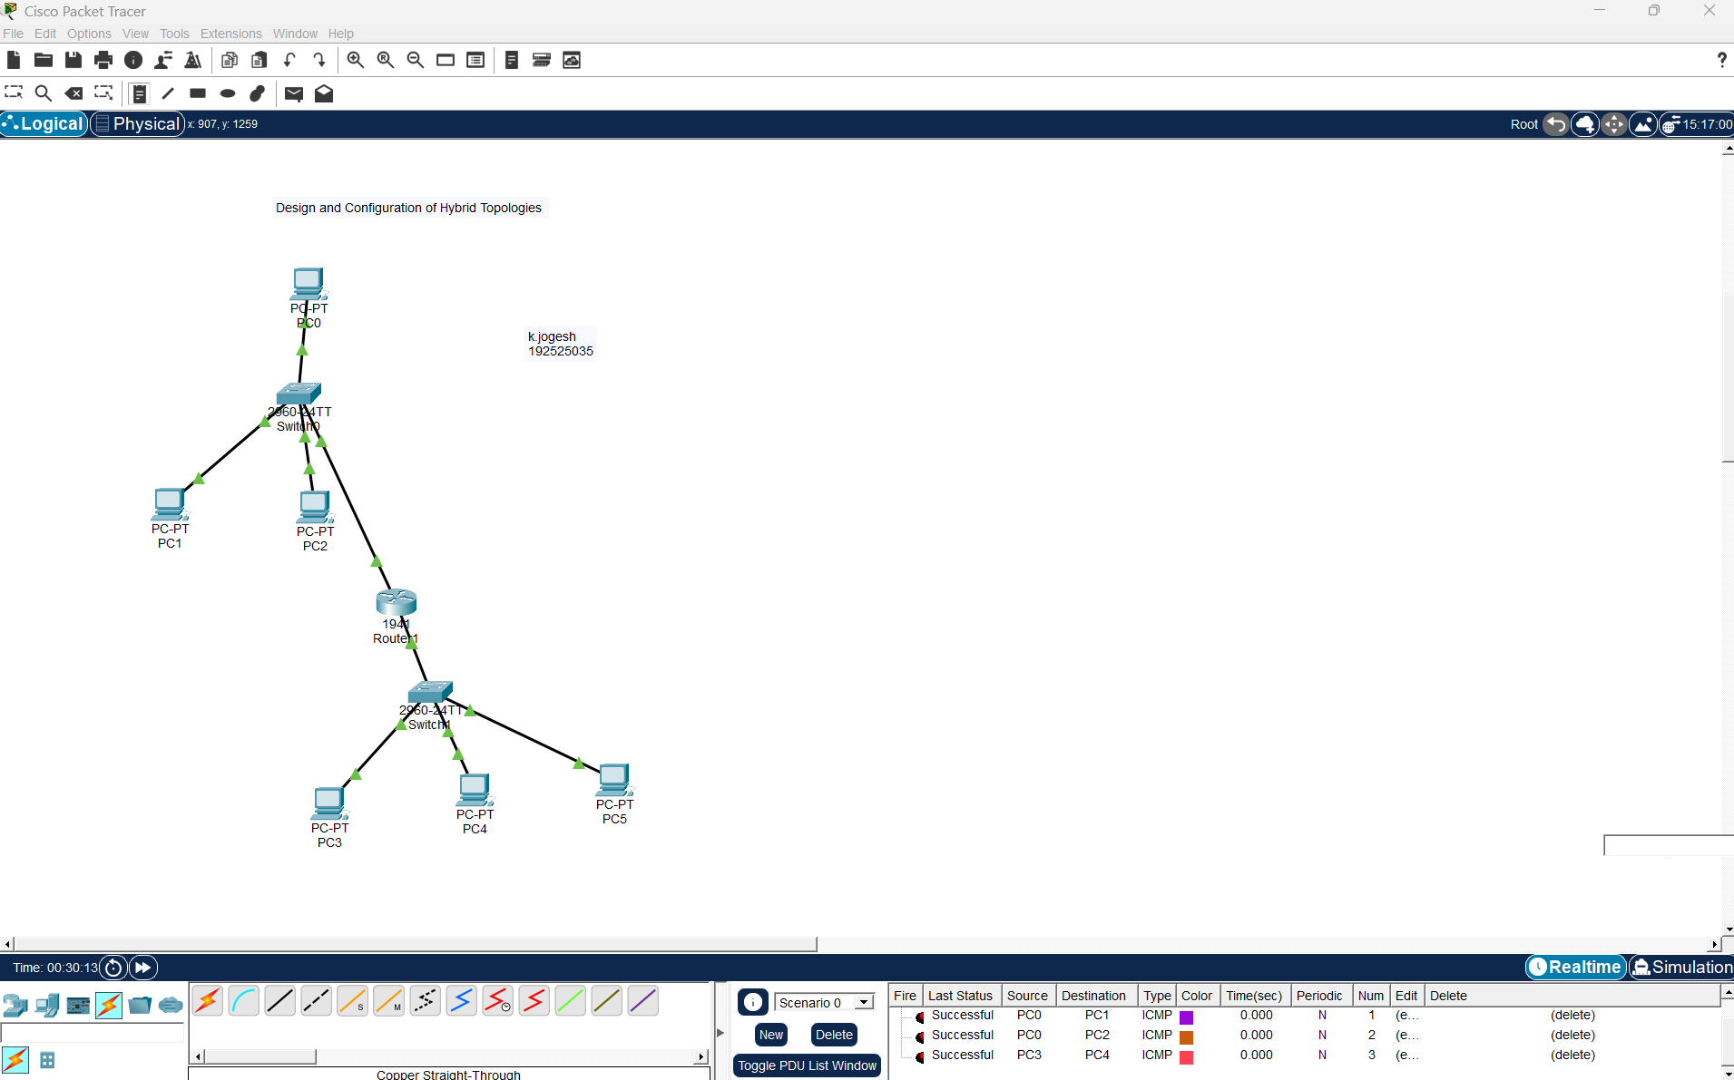

EX.8 Data Link Layer Traffic Simulation using Packet Tracer Analysis of ARP.
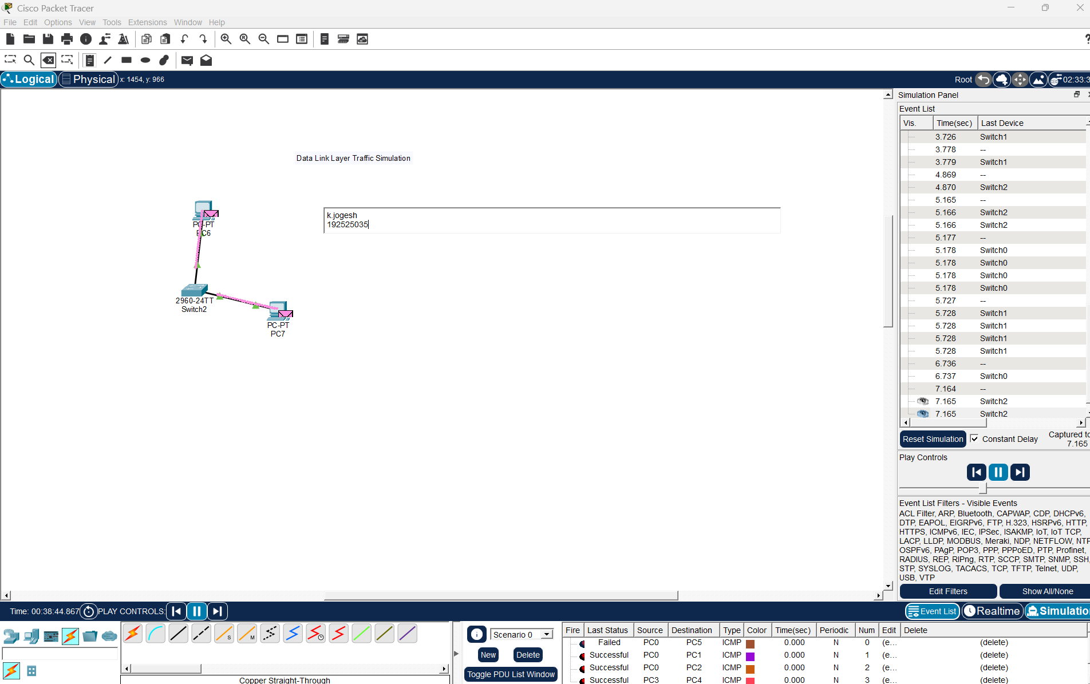

EX:9 Data Link Layer Traffic Simulation using Packet Tracer Analysis of CSMA/CD & CSMA/CA.
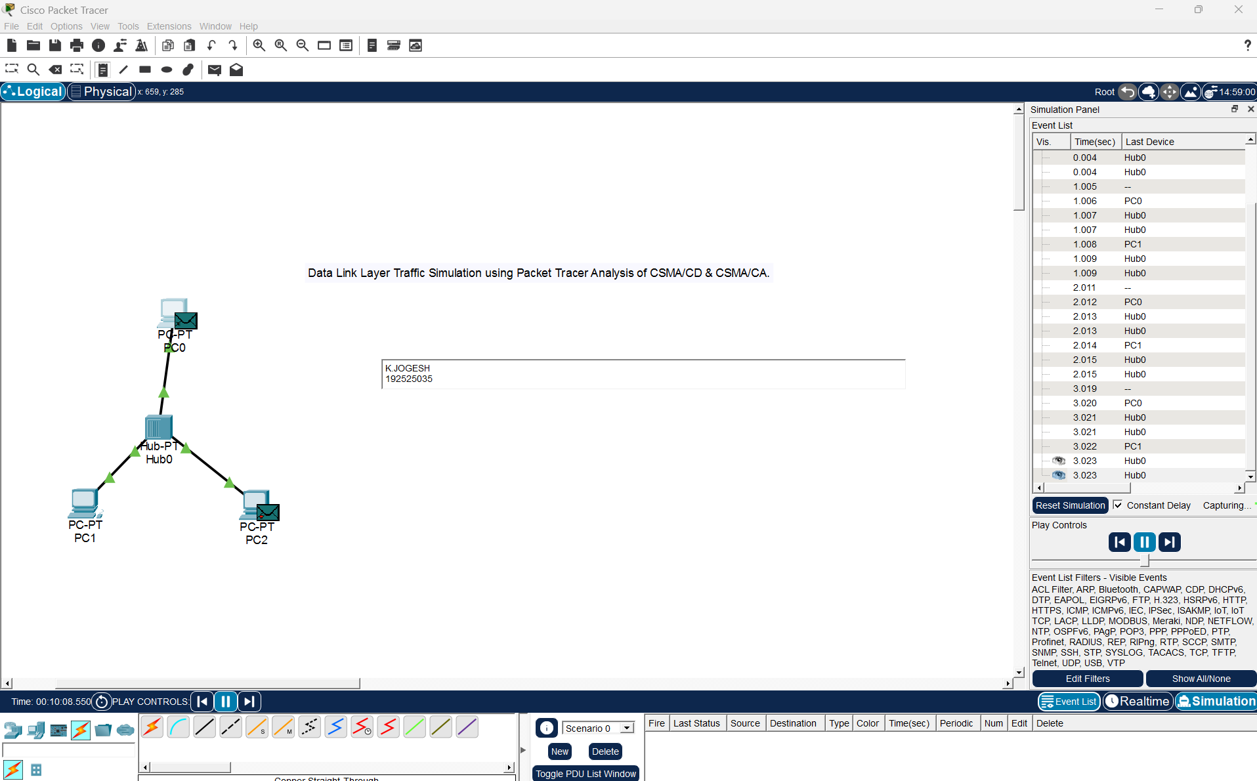

EX:10 Making Computer Lab in Cisco Packet Tracer.
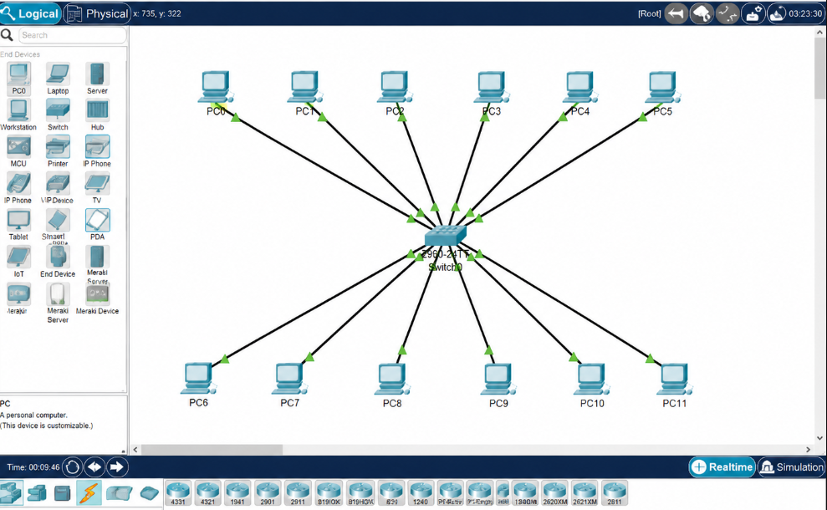
EX:11 Designing two different network with Static Routing techniques using Packet Tracer.
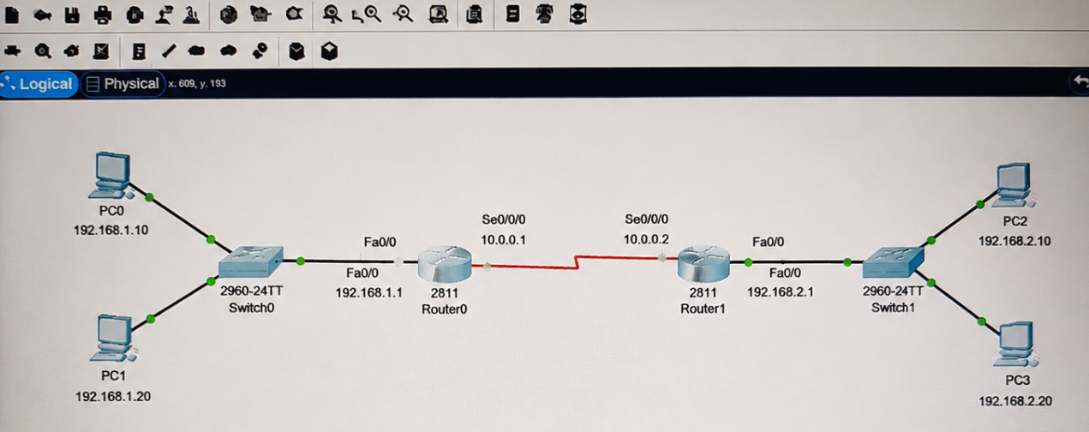

EX: 12 Design the Functionalities and Exploration of TCP using Packet Tracer.
